**Interactive Visualization of Global Malaria Cases**

**By [Jirui Zhang]**

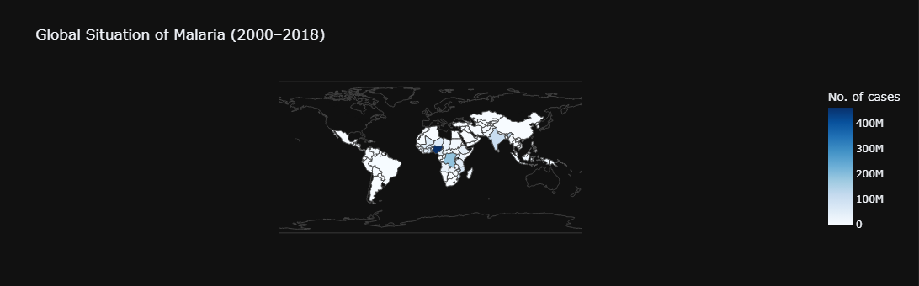**World Map: Global Situation of Malaria**

**Bar Chart: Top 20 Countries with Highest Malaria Case**

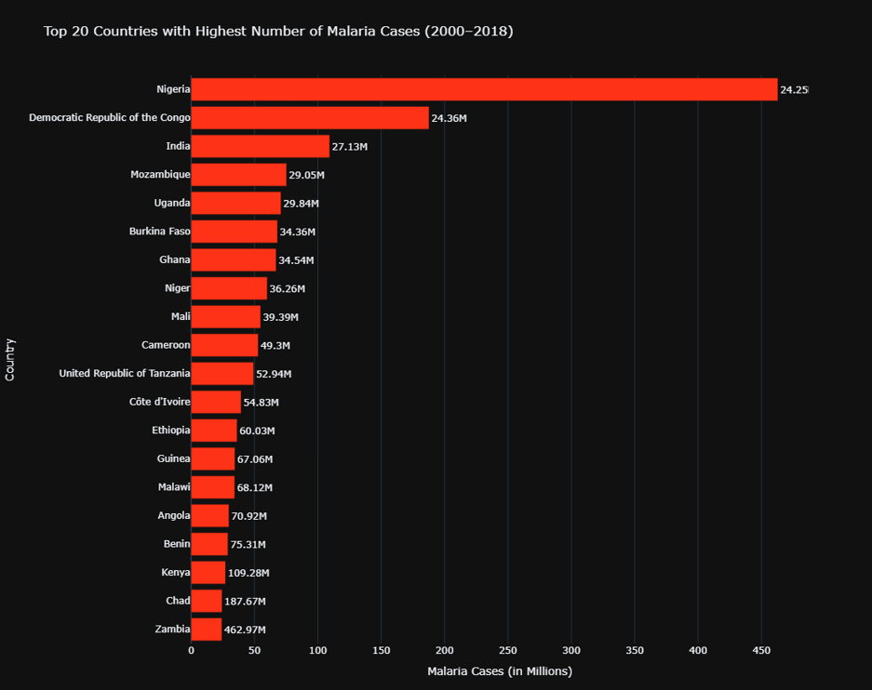

**Treemap: Malaria Cases and Deaths by Country**

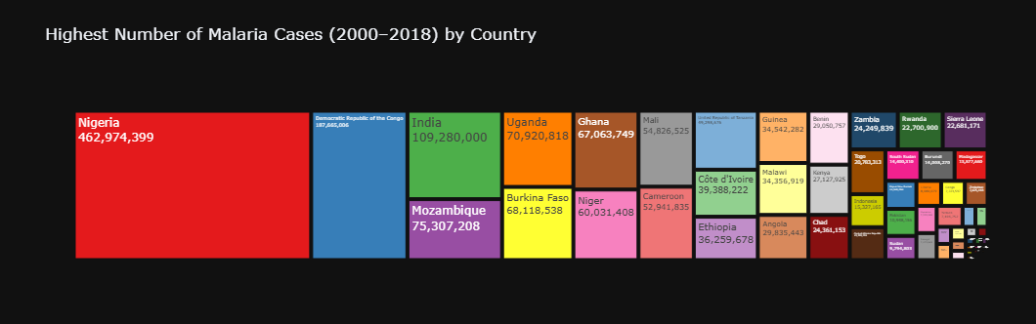

**Legend Explanation**

**World Map Color Gradient (White → Dark Blue):**

* **White:** Countries with no reported malaria cases or missing data.
* **Light Blue:** Countries with a lower number of reported malaria cases.
* **Dark Blue:** Countries with the highest reported malaria cases.
* The deeper the shade of blue, the higher the number of malaria cases reported over the period 2000–2018.

**Tree Map** **Size of Each Box:**

* Proportional to the total number of cases or deaths reported.
* Larger boxes shows greater burden.

**Color of Boxes:**

* Each country or region is assigned a distinct color using the Set1 qualitative palette.

**Bar chart**

**X-axis:**

* Represents the number of malaria cases (in millions), scaled for readability.
* Bars extend horizontally to indicate magnitude.

**Y-axis:**

* Lists the top 20 countries with the highest malaria cases between 2000 and 2018.

**Bar Length:**

* Proportional to the number of reported cases.
* Longer bars = more cases.

**Findings Highlights**

* Nigeria consistently appears at the top with over 400 million reported cases.
* Other highly affected countries include Democratic Republic of Congo, India, Uganda, Mozambique, and Burkina Faso.
* Sub-Saharan Africa stands out with the highest intensity of malaria cases.
* South and Southeast Asia (especially India and Indonesia) also show significant case numbers.
* Regions like North America, Europe, and Australia appear white, indicating no significant malaria burden.
* Treemaps visually reinforce that **a** few countries account for most cases and deaths.